Symphony Math ‘At Home’ Instructions
Congratulations! Your school has implemented Symphony Math, which entitles your child to use the program at home. Follow the instructions below to get started. Please be aware that all support issues must be directed to the technical staff at your school:

Support Contact:
Telephone:
Email:

Starting Symphony Math
Windows and Mac OS:  Type this web address in your web browser to sign in: mysymphonymath.com.  iPad:  Go to the App Store. Search for ‘Symphony Math’. Download and install the free app.  Your student’s Sign In information:  Account #:  Username:  Password: | 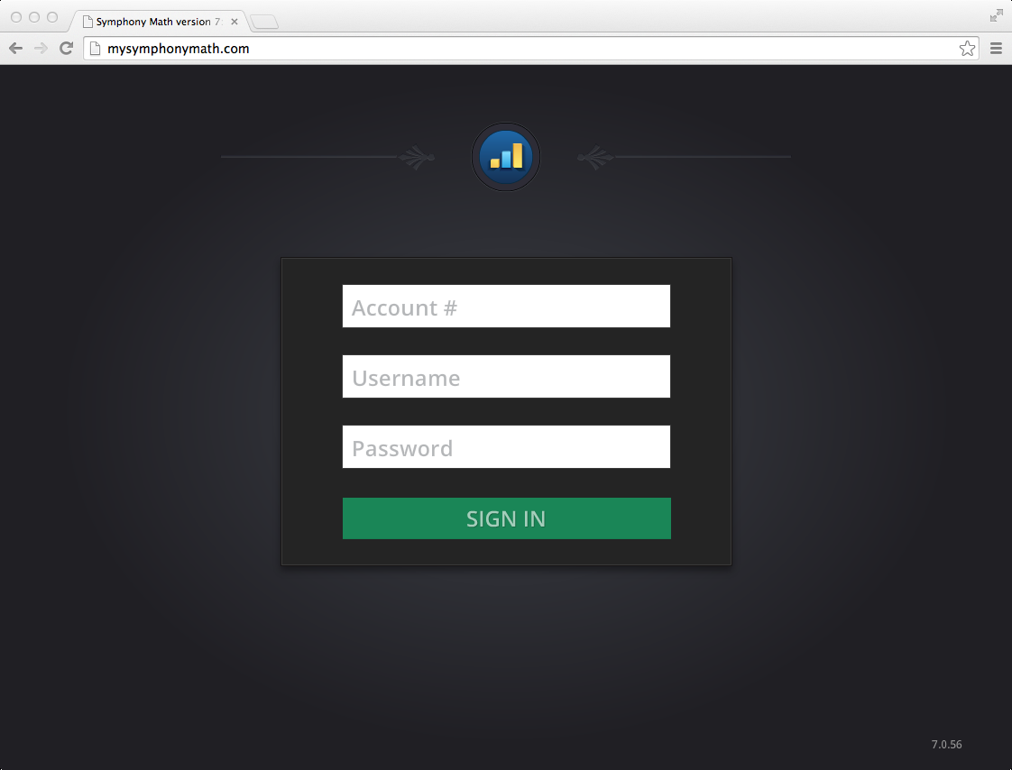

Using Symphony Math
During use of Symphony Math, the program automatically adjusts to your child’s learning style and skill level, so no additional configuration or adjustments are necessary. When your child asks for help, teach them to press the Lifesaver button for hints. The Lifesaver button is located at the top right of the screen and alerts the program that students are having trouble. The program will provide assistance with the current question and adjust the level of difficulty on subsequent questions.

